Nama : Astiany Dwi Prasinta

NIM : 18090059 (5D)

**PRAKTIKUM III**

1. Source Code

Matakuliah -> Application/Controller/Matakuliah.php

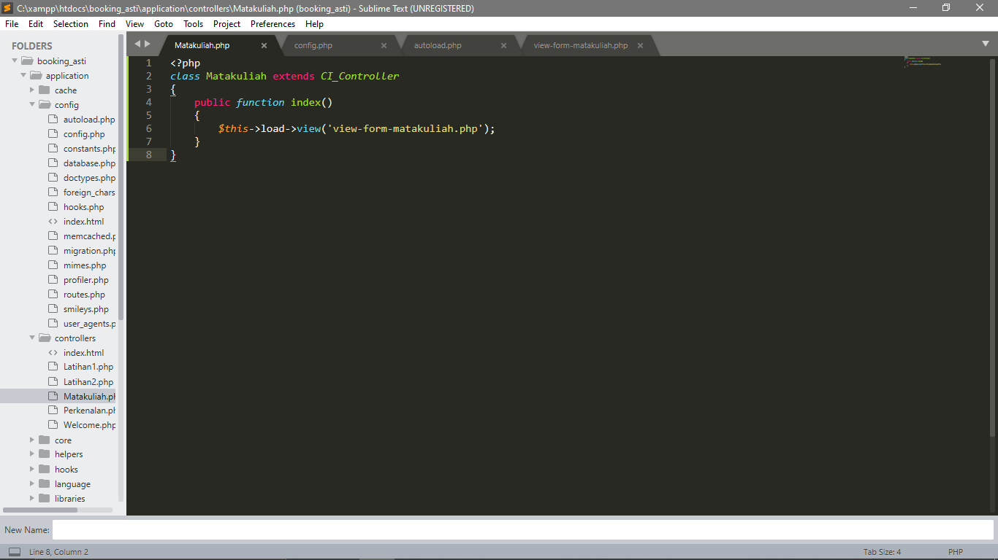

View-form-matakuliah -> Application/view/ View-form-matakuliah.php

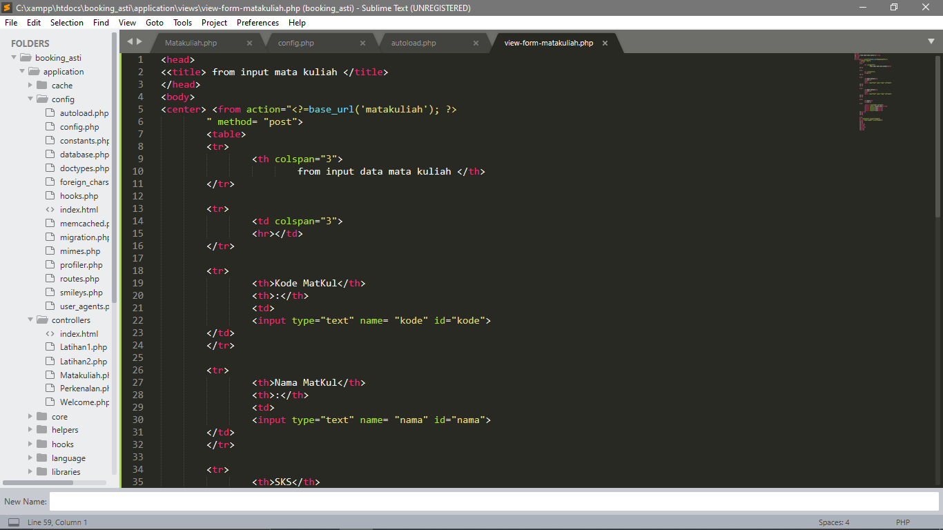

1. URL

<http://localhost/booking_asti/index.php/Matakuliah>

1. Output

